Crystal Engineering: From Structures to properties

Kumar Biradha
Department of Chemistry, Indian Institute of Technology, Kharagpur-721302, West Bengal
Email: kbiradha@yahoo.com
Crystal engineering deals with designing functional materials with predesigned architectures and functional properties. A thorough understanding of the intermolecular interactions, which control the crystal packing, is necessary in this context.^{1,2} Among the various intermolecular interactions hydrogen bonding and coordination bonding are the most important tools for the design of supramolecular assemblies because of their strength and directionality. Identification of robust interaction patterns, supramolecular synthons, for a given functional group, and utilization of such patterns for building higher dimensional structures in a predictive manner is hugely successful and well employed strategy in crystal engineering. In my presentation some of our recent results on design of 1) Co-crystals & Salts; 2) photochromic and photswitchable semiconductors; 3) post synthetic modification of coordination polymers & gas sorption; 4) [2+2] solid-state photochemical reactions for the synthesis of crystalline coordination polymers will be presented.³

1. a) G. R. Desiraju, Angew. Chem. Int. Ed. 1995, 34, 2311; b) M. J. Zaworotko, Chem. Commun. 2001, 1; c) K. Biradha, CrystEngComm, 2003, 374; d) K. Biradha and M. Fujita, "Layered Materials by Design:2D Coordination Polymeric Networks Containing Large Cavities/Channels" in Crystal Design: Structure and Function, ed. G. R. Desiraju, John Wiley Publishers, Vol. 7, 211, 2003; e) K. Biradha, L. Rajput, “Crystal Engineering with Molecules Containing Amide and Pyridine Functionalities”, in Organic Crystal Engineering: Frontiers in Crystal Engineering; E. R. T. Tiekink, J. J. Vittal, M. J. Zaworotko, Eds.; John Wiley Publishers: New York, 2010.
2. a) K. Biradha, M. Sarkar and L. Rajput, Chem. Commun. 2006, 4169; b) K. Biradha and R. Santra, Chem. Soc. Rev 2013, 42, 950-967.
3. a) M. Garai and K. Biradha, Chem Comm. 2014, 50, 3568-3570; b) G. Mukherjee and K. Biradha, Chem Comm. 2014, 50, 670-672; c) M. Garai and K. Biradha, Angew. Chem. Int. Ed. 2013, 52, 5548-5551; d) S. Samai, P. Ghosh and K. Biradha, Chem.Commun. 2013, 49, 4181-4183; e) R. Santra, M. Garai, D. Mondal and K. Biradha, Chem. Eur. J. 2013, 19, 489-493. f) S. Roy, S. Prakash, S. K. Ray and K. Biradha, Angew. Chem. Int. ed. 2012, 51, 12012-12015; g) G. Mukherjee and K. Biradha, Chem.Commun. 2012, 48, 4293-4295; h) S. Samai and K. Biradha Chem. Mater. 2012, 24, 1165-1173; i) R. Santra, K. Banerjee and K. Biradha, Chem.Commun. 2011, 47, 10740-10742.
.

A short CV of the Speaker

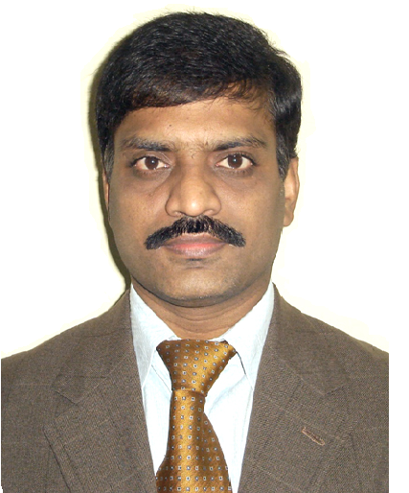

Speaker’s Name: Kumar Biradha
Kumar Biradha received his PhD in Chemistry from the University of Hyderabad (Hyderabad, India) in 1997 under the supervision of Prof. G. R. Desiraju. Subsequently he did his postdoctoral research with Professors M. J. Zaworotko (Halifax, Canada) and M. Fujita (Nagoya, Japan). Currently he is working as a Professor at the Indian Institute of Technology, Kharagpur, India. He is the author of over 150 research publications which covers his research interests in supramolecular chemistry, crystal engineering, and materials chemistry. He has received Scopus young scientist award in chemistry for 2006 by Elsevier and became FRSC in 2010. He served as editorial board member of New Journal of Chemistry, R. Sc. (2008-2011) and served as co-editor for Acta Cryst. Sec-E in 2011. Currently he is Associate Editor of Crystal Growth & Design, ACS publications.

Selected Important Contributions:
- K. Biradha, CrystEngComm, 2003, 374
- M. Sarkar, K. Biradha, CrystEngComm, 2004, 6, 310-314.
- M. Sarkar, K. Biradha, Chem. Commun., 2005, 2229-2231.
- K. Biradha, M. Sarkar, L. Rajput, Chem. Commun. 2006, 4169.
- M, Sarkar, K. Biradha, Crystal Growth & Design, 2006, 6, 202-208.
- M. Sarkar, K. Biradha Crystal Growth & Design 2007, 7, 1318-1331
- R. Santra, K. Biradha, CrystEngComm, 2008, 10, 1524-1526.
- K. Biradha, A. Ramanan, J. J. Vittal, Crystal Growth & Design, 2009, 9, 2969-2970
- L. Rajput, V. V. Chernyshev, K. Biradha, Chem. Commun. 2010, 46, 6530
- R. Santra, K. Banerjee, K. Biradha, Chem.Commun. 2011, 47, 10740-10742.
- S. Roy, S. Prakash, S. K. Ray, K. Biradha, Angew. Chem. Int. ed. 2012, 51, 12012.
- S. Samai, K. Biradha, Chem. Mat. 2012, 24, 1165-1173.
- K. Biradha, R. Santra, Chem. Soc. Rev 2013, 42, 950-967.
- M. Garai, K. Biradha, Angew. Chem. Int. Ed. 2013, 52, 5548-5551;
- S. Samai, P. Ghosh, K. Biradha, Chem.Commun. 2013, 49, 4181-4183;
- G. Mukherjee, K. Biradha, Chem Comm. 2014, 50, 670-672;
- S. Roy, A. Katiyar, S. Mondal, S. Ray, K. Biradha, ACS Applied Materials & Interfaces 2014, 6, 11493-11501.

